Year 8 |  | Further Algebraic Techniques | Non Calculator  Section
 |  |  | Name___________________
  Skills and Knowledge Assessed:
  - Create algebraic expressions and evaluate them by substituting a given value for each variable (ACMNA176)
  - Extend and apply the distributive law to the expansion of algebraic expressions (ACMNA190)
  - Factorise algebraic expressions by identifying numerical factors (ACMNA191)
  - Factorise algebraic expressions by identifying algebraic factors.
  - Simplify algebraic expressions involving the four operations (ACMNA192)
Answer all questions in the spaces provided on this test paper by:
Writing the answer in the box provided.
or
Shading in the bubble for the correct answer from the four choices provided.
Show any working out on the test paper. Calculators are not allowed.
Simplify
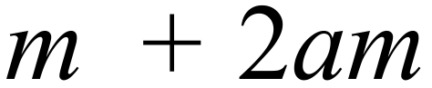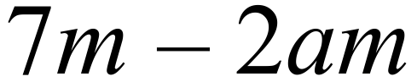
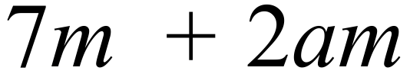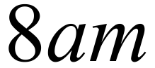
Simplify 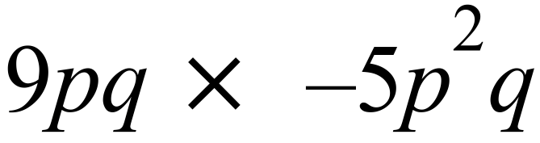
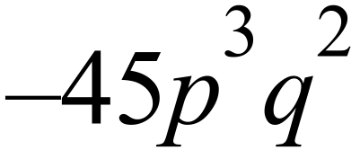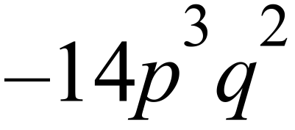
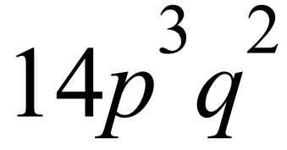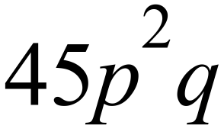
?

29 48 168 320
Which product below gives an answer of 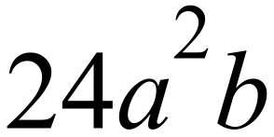
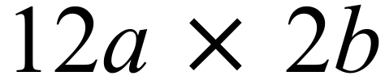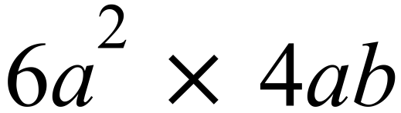
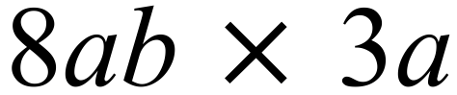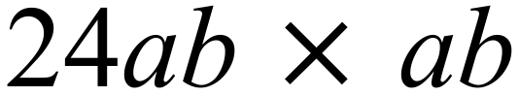
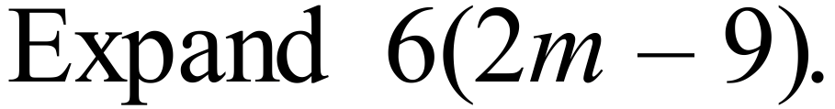

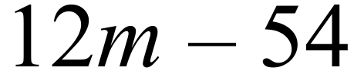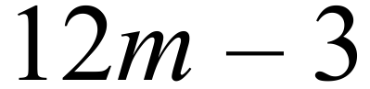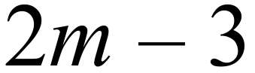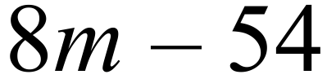
 | 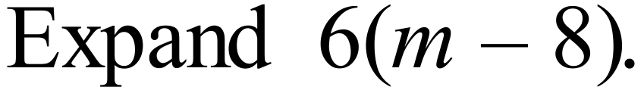
 | 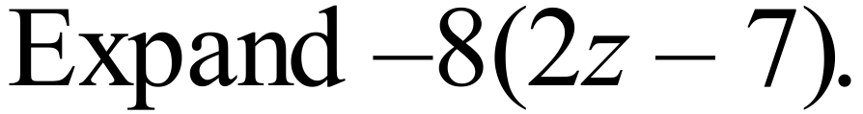
The table below is completed by substituting the x values given into 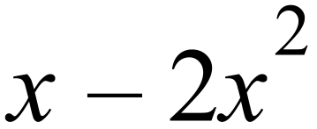
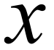 | 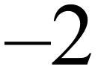 | 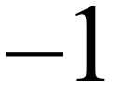 |  | 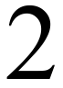
 | 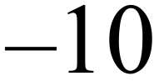 | 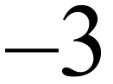 | A | B

What two values should replace A and B?

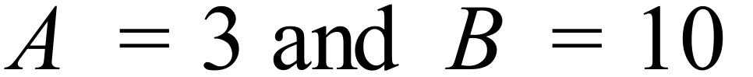
 | 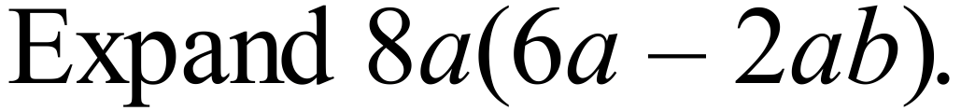
 | 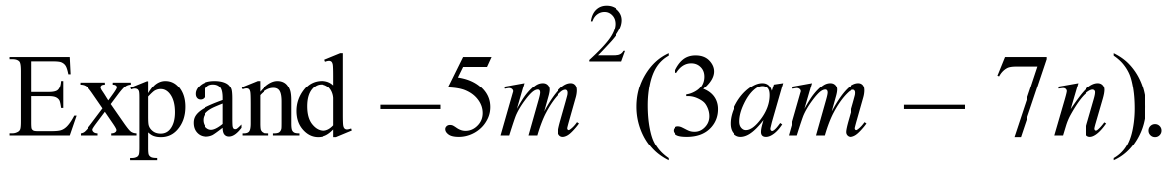
Which is not a factor of 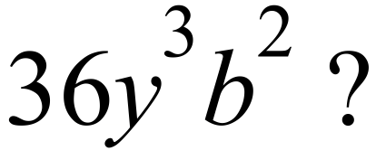

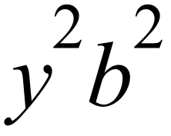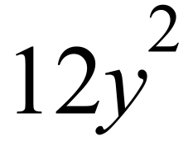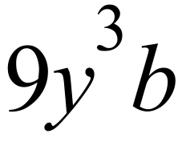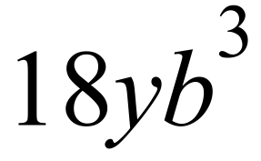
Factorise 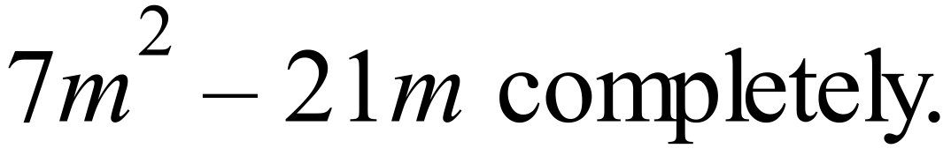

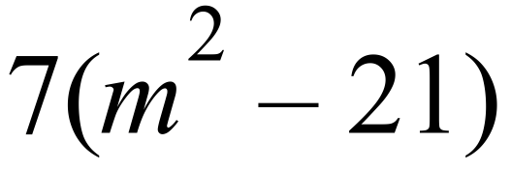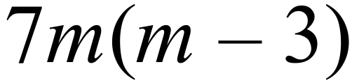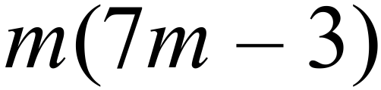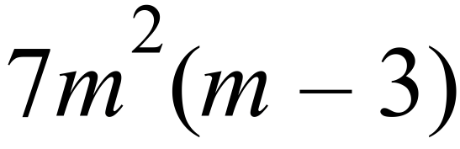
 | Factorise 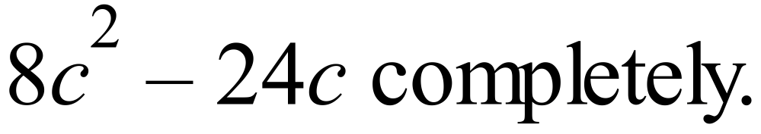
 | Factorise 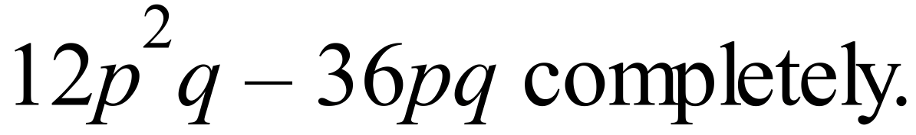
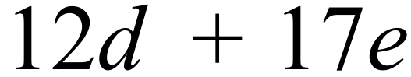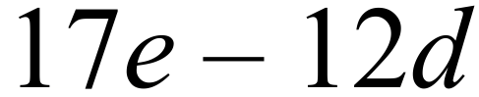
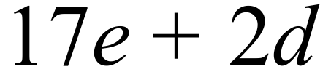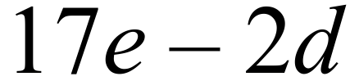
Factorise 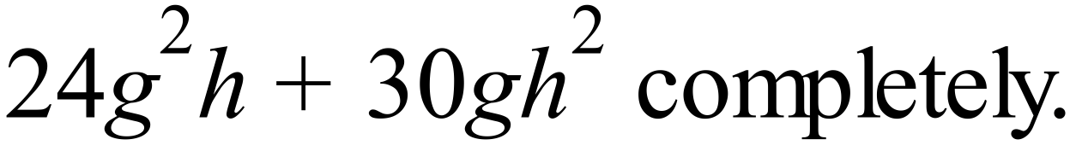

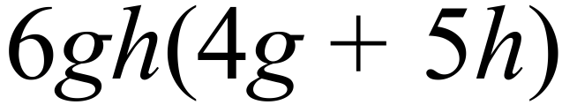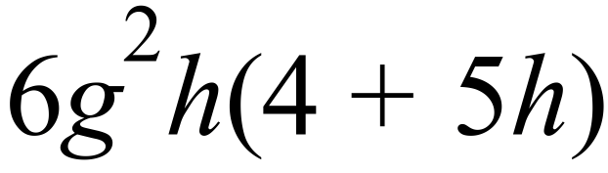
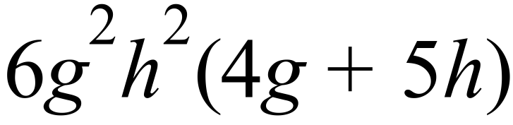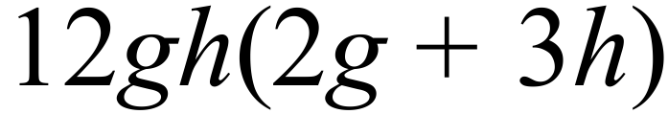
 | Factorise 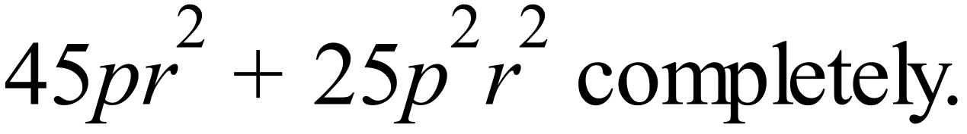
Simplify 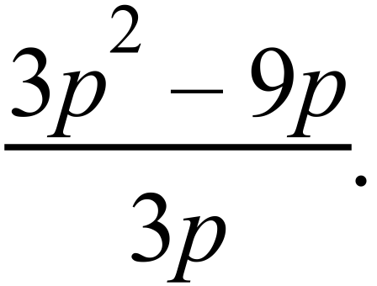

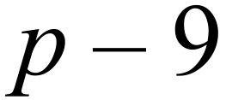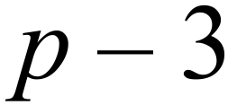
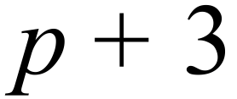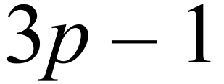
Complete the table of values below.

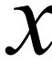 | 0 | 1 | 2 | 3
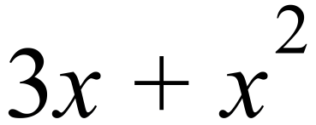

Year 8 |  | Further Algebraic Techniques | Calculator Allowed  Short Answer  Section
 |  |  | Name___________________
Answer all questions in the spaces provided on this test paper by:
Writing the answer in the box provided.
or
Shading in the bubble for the correct answer from the four choices provided.
Show any working out on this test paper. Calculators are allowed.
Simplify 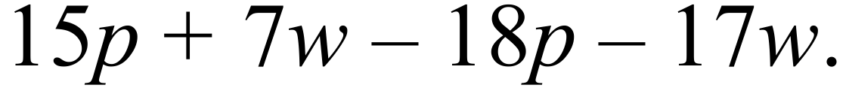
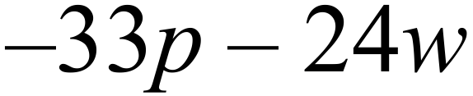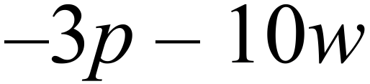
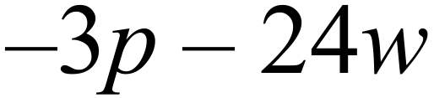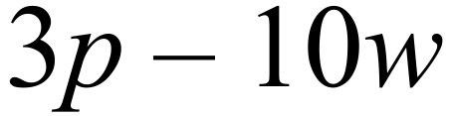
Simplify 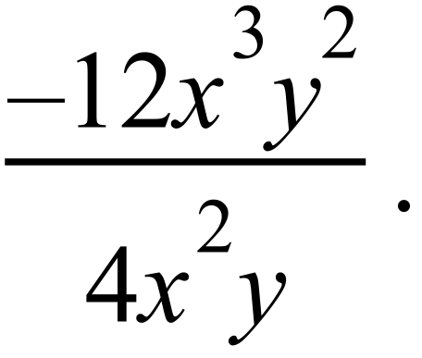
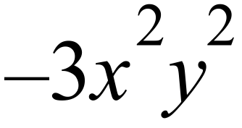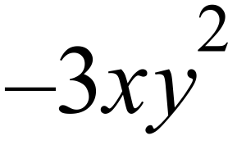
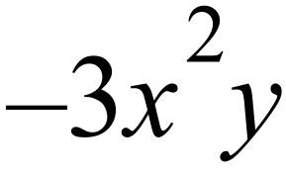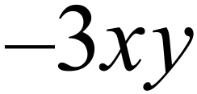
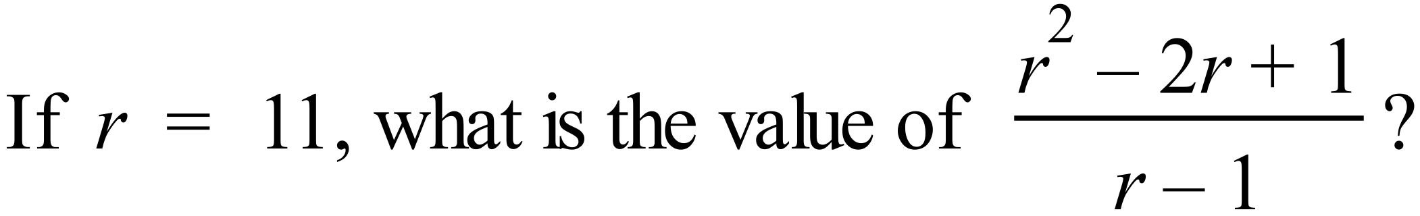

10 11.1 12.2 13.2
Write two algebraic terms which have a product of 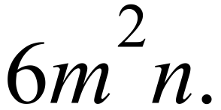

× = 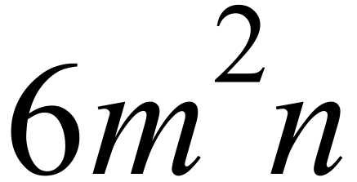
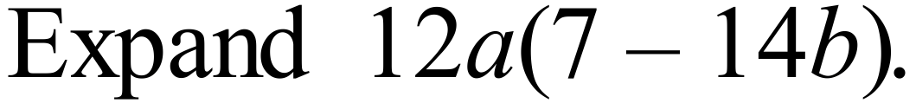

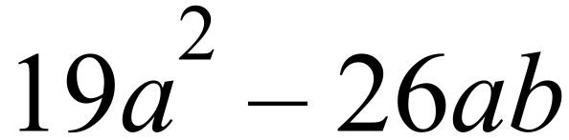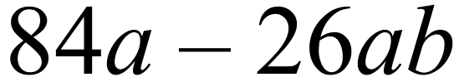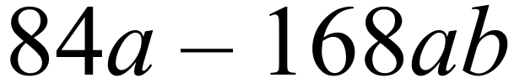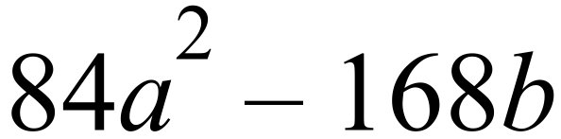
 | 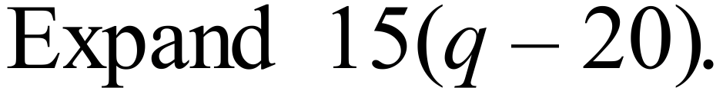
 | 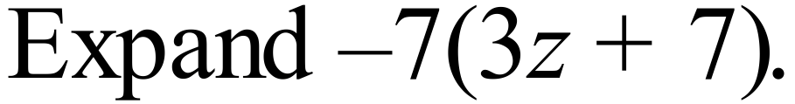
 | Complete the table below by substituting the x values given into 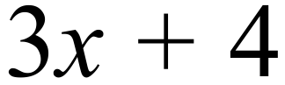
 | 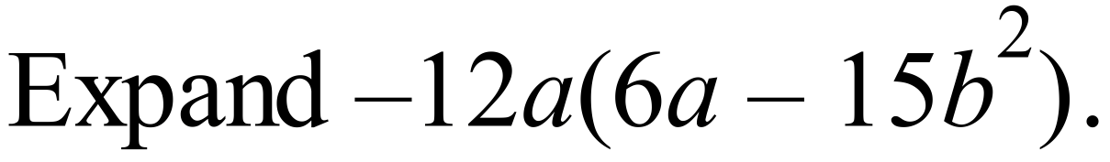
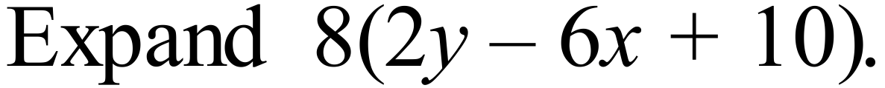

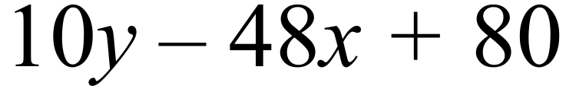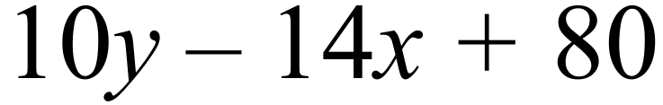
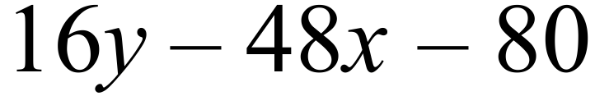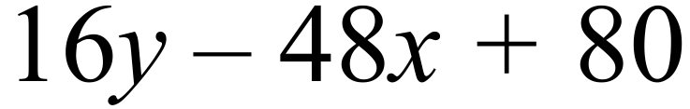
Factorise 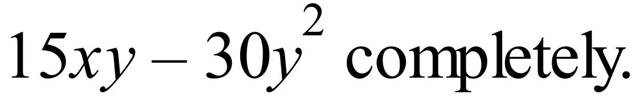

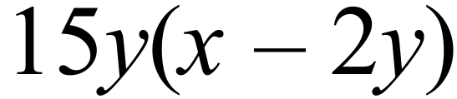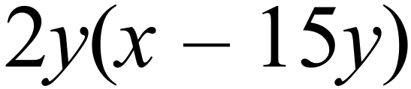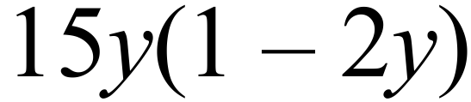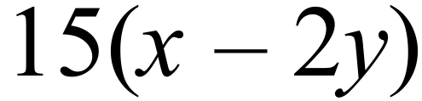
 | Factorise 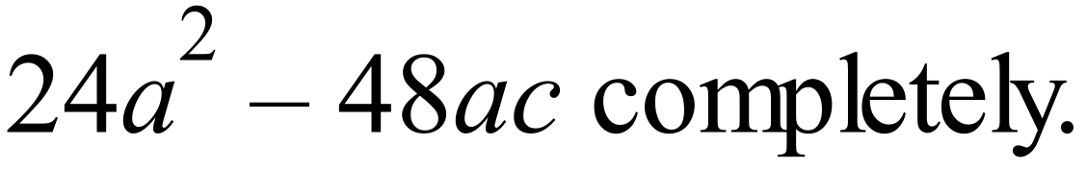
 | Factorise 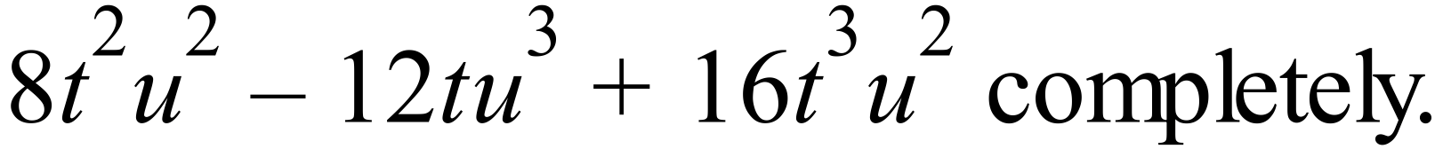
 | 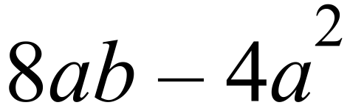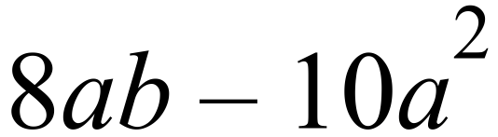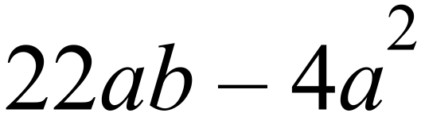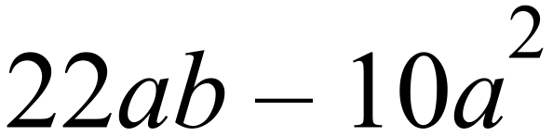
Factorise 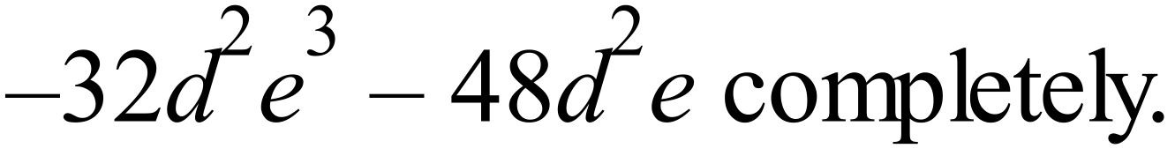

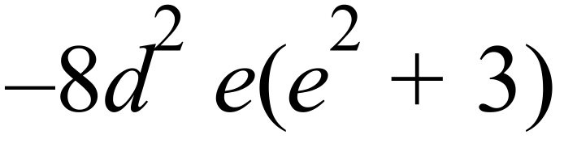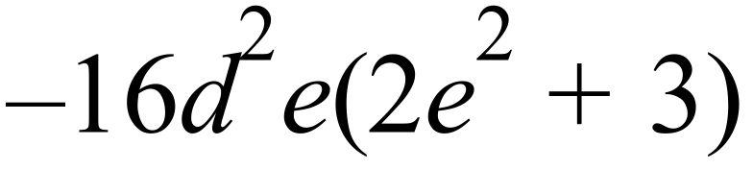
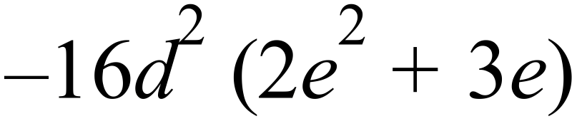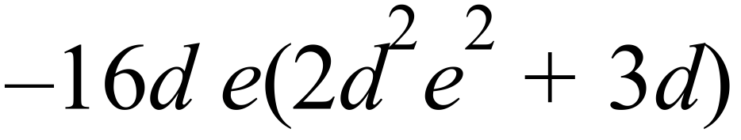
 | Factorise 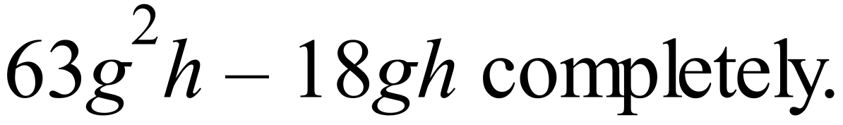
Simplify 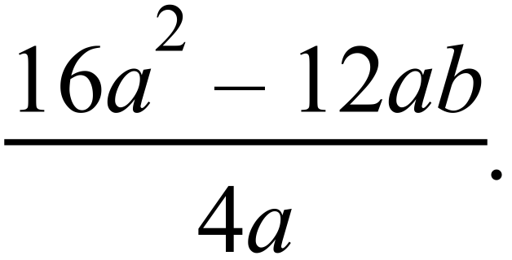

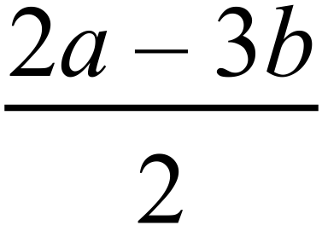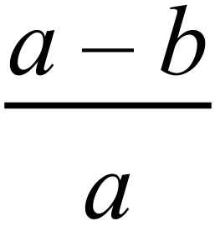
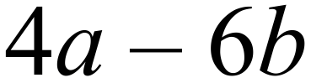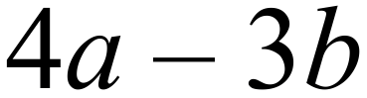
 | Simplify 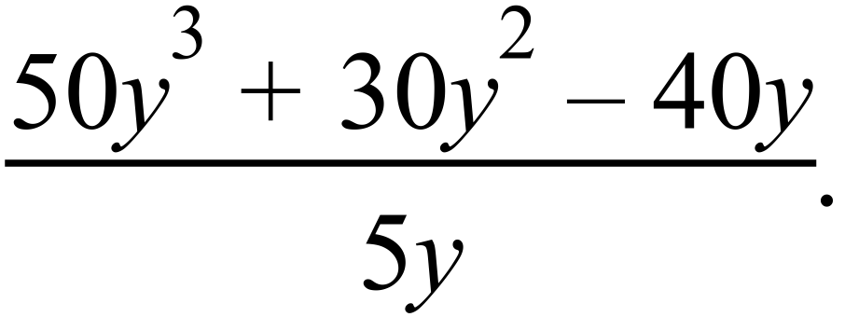

Year 8 |  | Further Algebraic Techniques | Non Calculator  Section
ANSWERS
No. | WORKING |  | ANSWER
 |  |  | 3rd answer
 | 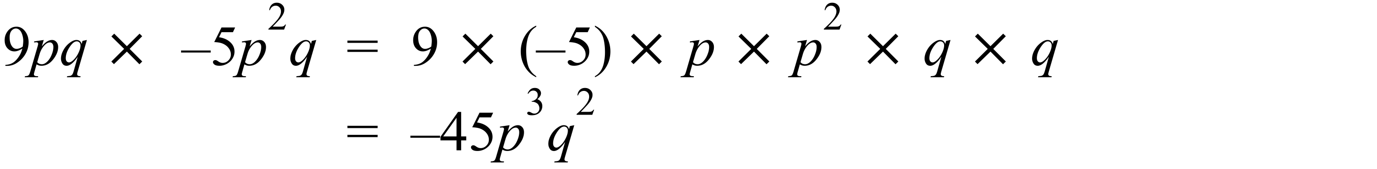 |  | 1st answer
 | 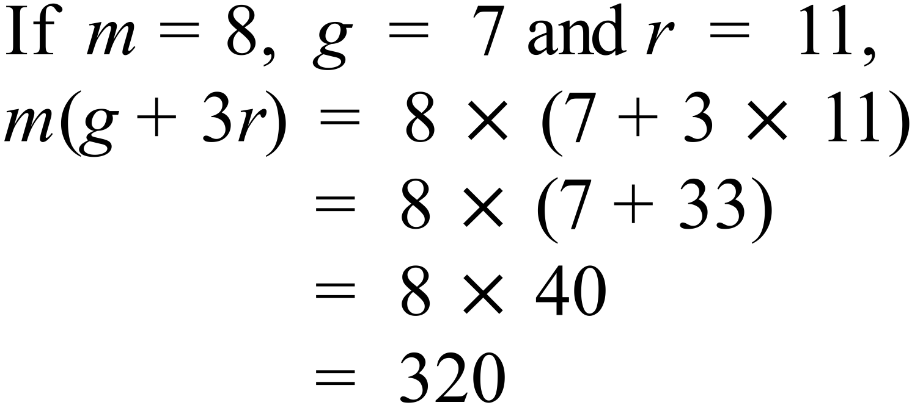 |  | 4th answer
 | 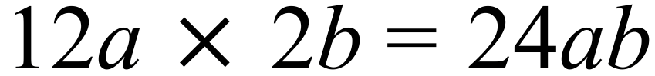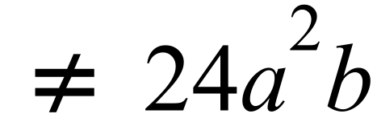  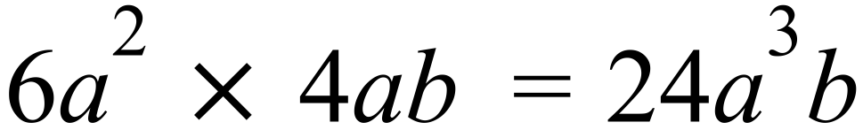  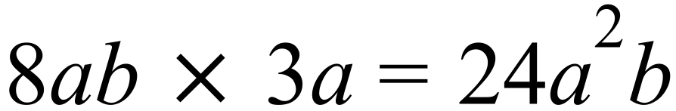  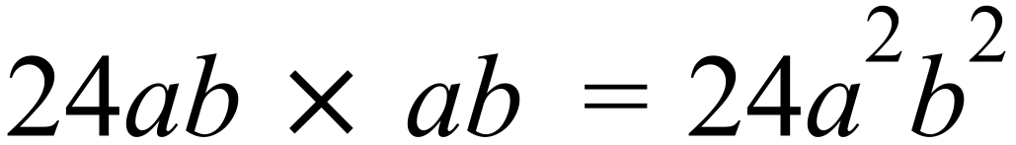 |  | 3rd answer
 |  |  | 1st answer
 | 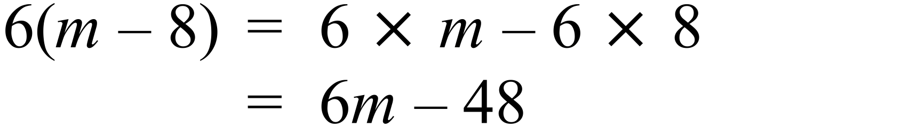 |  | 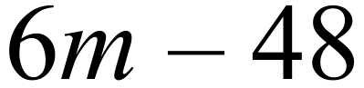
 | 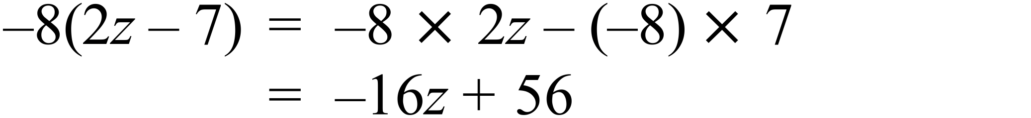 |  | 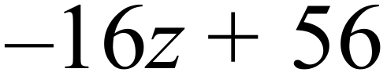
 |  |  | 2nd answer
   | 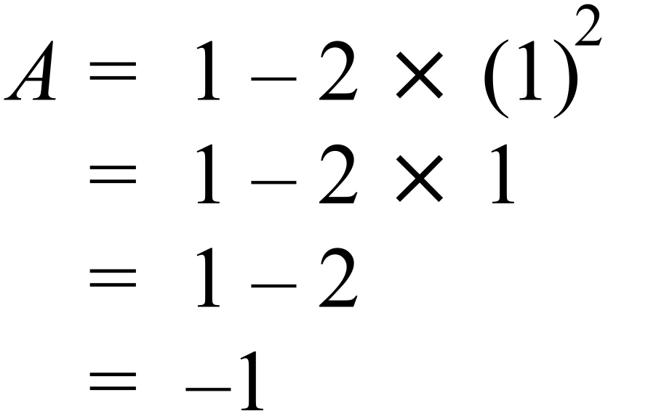 | 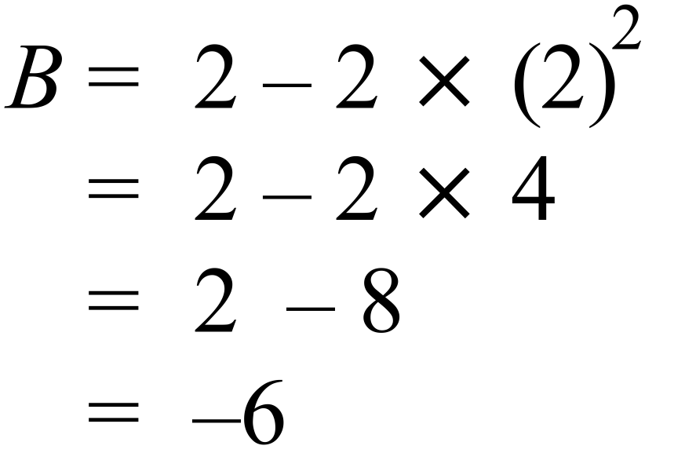
 | 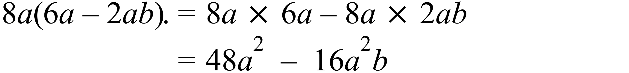 |  | 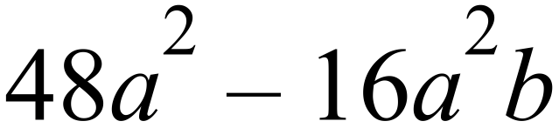
 | 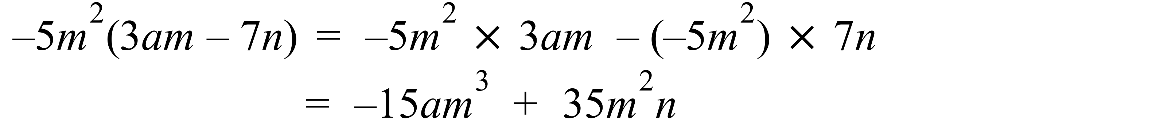 |  | 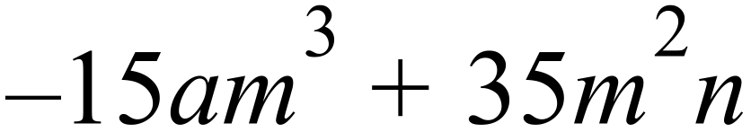
 | 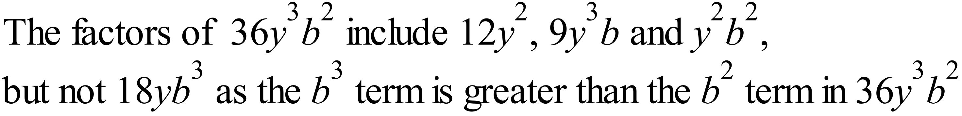 |  | 4th answer
 | 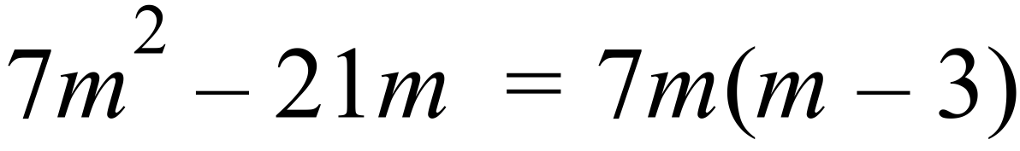 |  | 2nd answer
 | 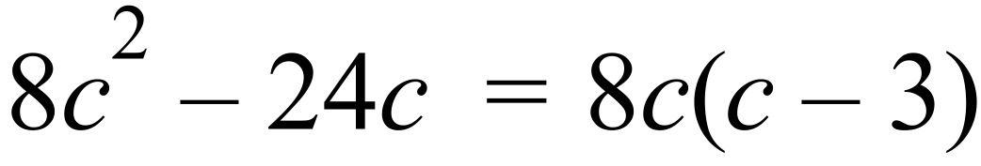 |  | 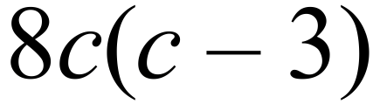
 | 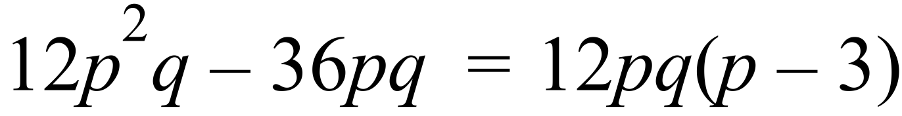 |  | 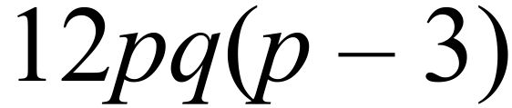
 | 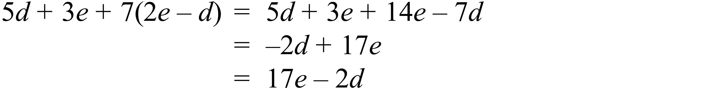 |  | 4th answer
 |  |  | 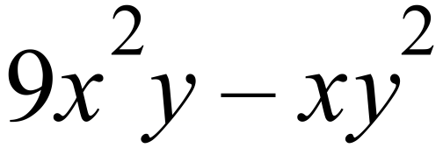
 | 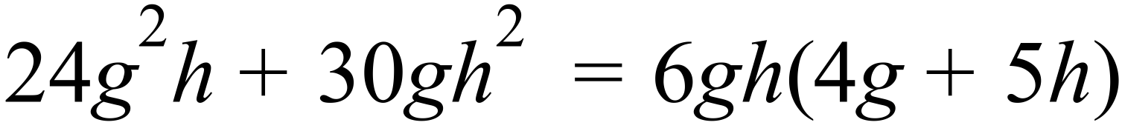 |  | 1st answer
 | 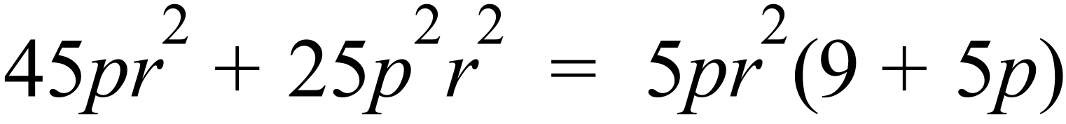 |  | 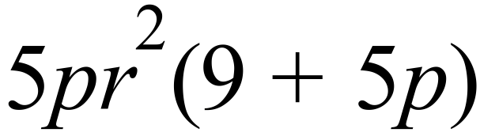
 | 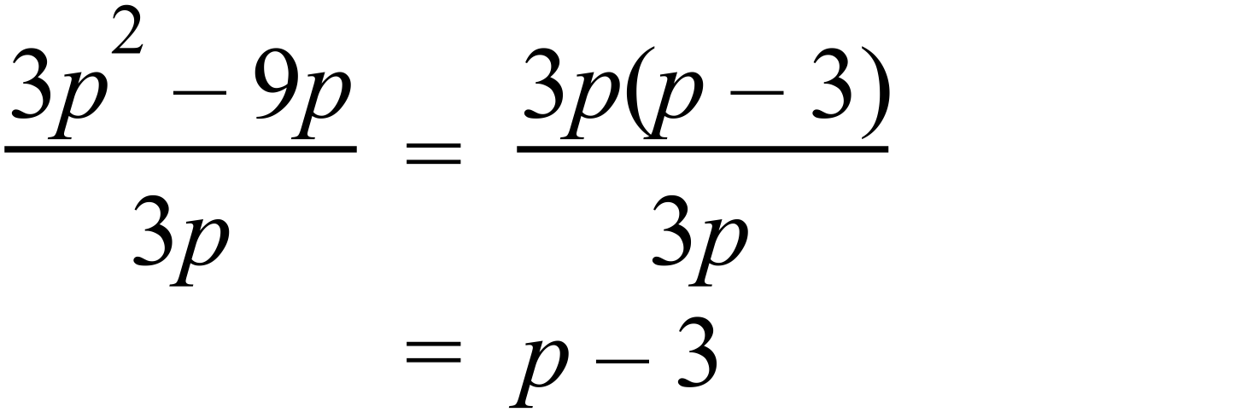 |  | 2nd answer
 |  |  | 4 answers in table.
   | 0 | 1 | 2 | 3
   | 0 | 4 | 10 | 18

Year 8 |  | Further Algebraic Techniques | Calculator Allowed  Short Answer  Section
ANSWERS
No. | WORKING |  |  | ANSWER
 |  |  |  | 2nd Answer
 | 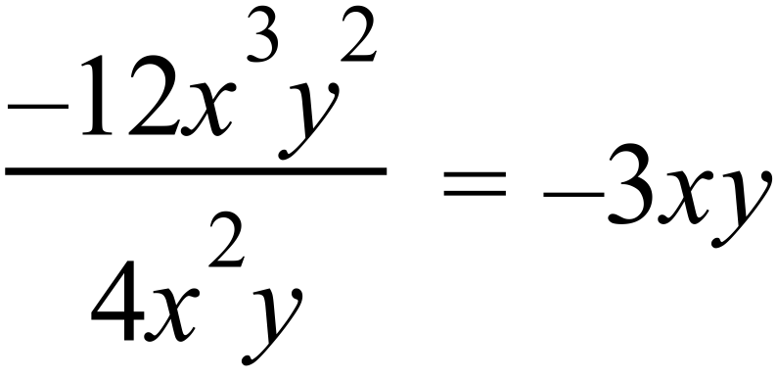 |  |  | 4th Answer
 | 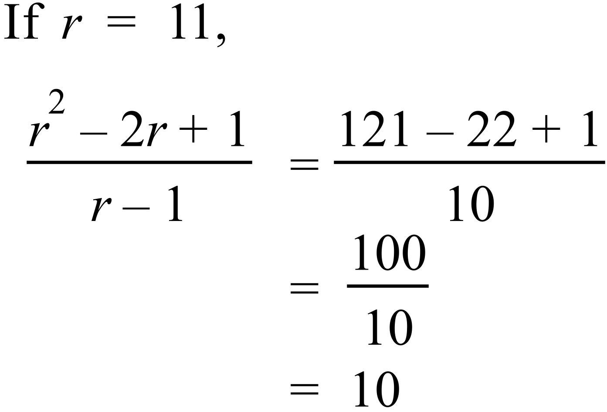 |  |  | 1st Answer
 | Several possibilities.  e.g. |  |  | Any two terms with required product.
 |  |  |  | 3rd Answer
 |  |  |  | 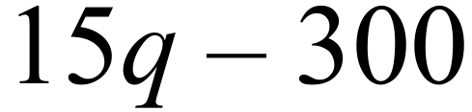
 | 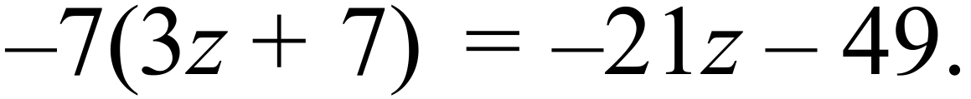 |  |  | 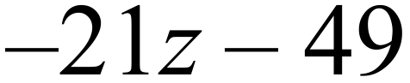
 |  |  |  | 7 and 10 in last 2 boxes
   |  |  | 7 | 10
 | 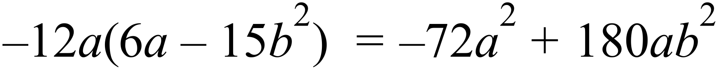 |  |  | 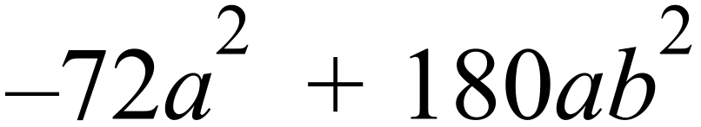
 |  |  |  | 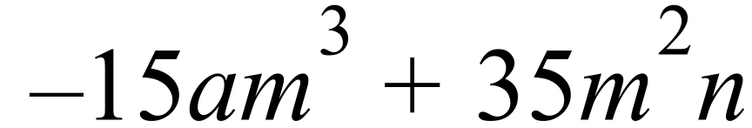
 |  |  |  | 4th Answer
 | 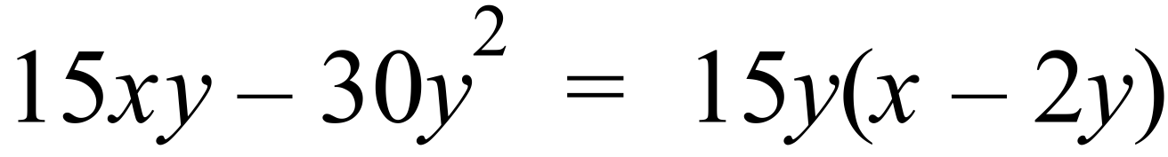 |  |  | 1st Answer
 | 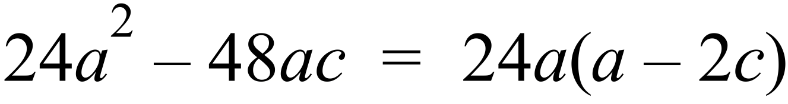 |  |  | 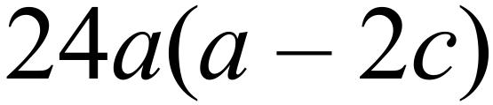
 |  |  |  | 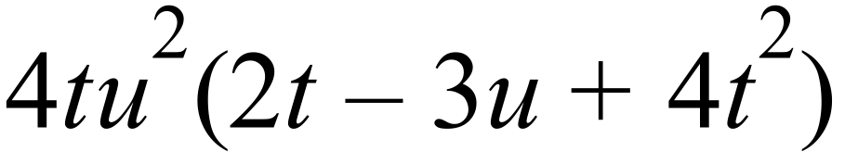
 |  |  |  | 3rd Answer
 |  |  |  | 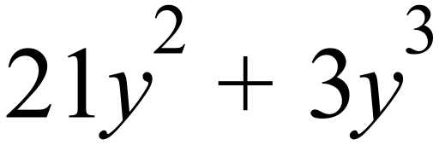
 |  |  |  | 2nd answer
 | 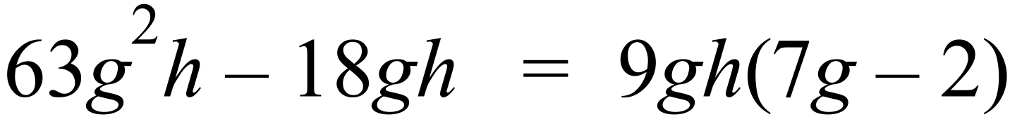 |  |  | 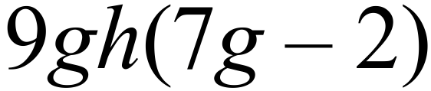
 | 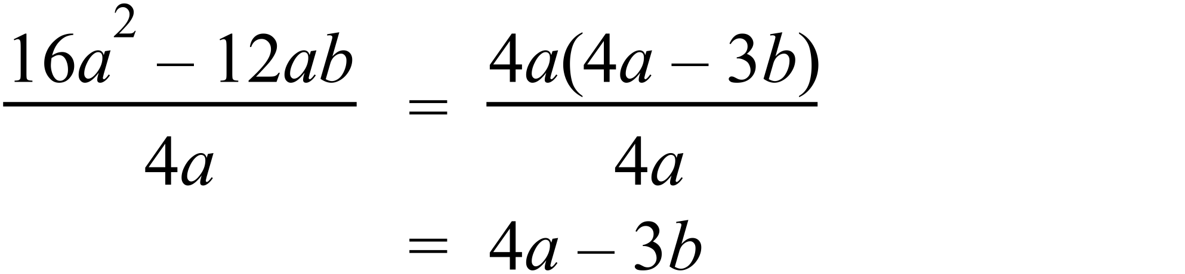 |  |  | 4th answer
 | 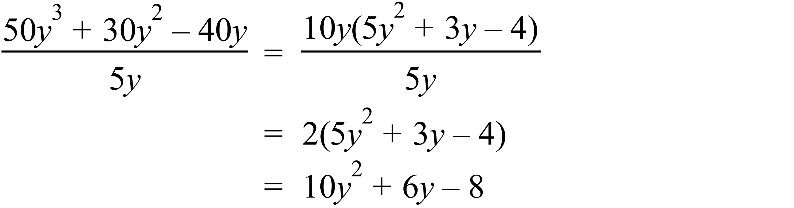 |  |  | 